Week 7-8: 10-13July 2026
1. Error injection (literature review)
Results details in week 7 report.

2 Software Prunibility
Results of version 1 (latency/accuracy_drop) in week 7 report.

For each layer i:
AccuracyDrop(i) = Avg(|mAP50-95 Drop(i)|), noise std ratio = 1.0 to 2.0, step = 0.2
$$Params\%(i)=\frac{Params\left(i\right) × 100}{TotalParams}$$
$$\text{SWPrunability}\text{(}\text{i}\text{)}=\frac{Params\%(i)}{AccuracyDrop(i)}$$

A higher score means that the layer occupies a larger portion of the model parameters but has lower accuracy sensitivity.

Layer ID | Type | Params  (2,508,090) | Params (%) | Avg mAP50-95 Drop 1–2 | SW Score
20 | Conv | 147712 | 5.889422 | 0.004854 | 1213.229794
7 | Conv | 295424 | 11.778844 | 0.057414 | 205.157489
22 | C3k2 | 463104 | 18.464409 | 0.112209 | 164.553727
10 | C2PSA | 249728 | 9.956899 | 0.064518 | 154.327466
8 | C3k2 | 346112 | 13.799824 | 0.128995 | 106.979386
17 | Conv | 36992 | 1.474907 | 0.020264 | 72.785202
13 | C3k2 | 119808 | 4.776862 | 0.073697 | 64.817592
6 | C3k2 | 87040 | 3.470370 | 0.053956 | 64.318119
9 | SPPF | 164608 | 6.563082 | 0.119105 | 55.103559
5 | Conv | 147712 | 5.889422 | 0.196045 | 30.041122
19 | C3k2 | 95232 | 3.796993 | 0.147826 | 25.685613
4 | C3k2 | 26080 | 1.039835 | 0.067078 | 15.501995
16 | C3k2 | 34304 | 1.367734 | 0.100157 | 13.655878
3 | Conv | 36992 | 1.474907 | 0.341082 | 4.324203
2 | C3k2 | 6640 | 0.264743 | 0.138414 | 1.912689
1 | Conv | 4672 | 0.186277 | 0.379612 | 0.490704
0 | Conv | 464 | 0.018500 | 0.467164 | 0.039601
23 | Detect | 245466 | 9.786969 | 0.506632~ | –
11 | Upsample | 0 | 0.000000 | 0.028861 | 0.000000
12 | Concat | 0 | 0.000000 | 0.062206 | 0.000000
14 | Upsample | 0 | 0.000000 | 0.031456 | 0.000000
15 | Concat | 0 | 0.000000 | 0.065628 | 0.000000
18 | Concat | 0 | 0.000000 | 0.032434 | 0.000000
21 | Concat | 0 | 0.000000 | 0.009906 | 0.000000
Table 2.2: SW Prunability Table 2

Table 2.2 presents the updated SW Prunability score. Since the main purpose of software pruning is to reduce model size, the previous latency percentage is replaced by the layer parameter percentage.

Based on the updated ranking, L20 Conv has the highest SW Prunability score because it has a non-trivial parameter percentage but very small accuracy drop. L7 Conv, L22 C3k2, L10 C2PSA, and L8 C3k2 are also strong candidates because they contain many parameters while their average mAP50-95 drops are relatively moderate.

In contrast, L0 Conv, L1 Conv, and L3 Conv should be avoided for aggressive pruning because their accuracy drops are high compared with their parameter percentages.

3. Pruning

Pruning Method | Search Type | Runs | Drop ≤ 0.02 | Drop ≤ 0.05 | Drop ≤ 0.10
L2 structured | Single-layer sweep | 102 | 8 | 20 | 30
L2 structured | New Top-6 combo | 126 | 2 | 8 | 20
L1 unstructured | Single-layer sweep | 102 | 93 | 96 | 98
L1 unstructured | New Top-6 combo | 126 | 126 | 126 | 126
Table 3.1:

This table shows that L2 structured pruning is much more accuracy-sensitive, while L1 unstructured pruning is very tolerant.

Metric | Value
Baseline mAP50-95 | 0.506632
Baseline mAP50 | 0.690055
Mean baseline latency | 1.384509 ms
Median baseline latency | 1.366112 ms
Mean baseline FPS | 725.054
Median baseline FPS | 732.004
Table 3.2:

Layers | Size | Amount | mAP50-95 | Drop | Zero % | Latency ms | FPS
7 | 1 | 0.10 | 0.496558 | 0.010075 | 1.260212 | 1.320066 | 757.538
8 | 1 | 0.05 | 0.492803 | 0.013829 | 0.705559 | 1.279845 | 781.345
7 | 1 | 0.05 | 0.503190 | 0.003443 | 0.630169 | 1.526256 | 655.198
20 | 1 | 0.10 | 0.489231 | 0.017401 | 0.630169 | 1.322812 | 755.965
10 | 1 | 0.05 | 0.489093 | 0.017540 | 0.519356 | 1.355747 | 737.601
9 | 1 | 0.05 | 0.490896 | 0.015737 | 0.344765 | 1.368557 | 730.696
Table 3.3:

L7 at 10% L2 structured pruning is the best strict structured candidate. It has higher zero percentage than L20 and a smaller mAP50-95 drop.

Layers | Size | Amount | mAP50-95 | Drop | Zero % | Latency ms | FPS
7 | 1 | 0.20 | 0.476630 | 0.030002 | 2.471833 | 1.388977 | 719.954
20,7 | 2 | 0.10 | 0.480049 | 0.026583 | 1.890255 | 1.383748 | 722.675
7,17 | 2 | 0.10 | 0.460691 | 0.045942 | 1.405607 | 1.325710 | 754.313
7 | 1 | 0.10 | 0.496558 | 0.010075 | 1.260212 | 1.320066 | 757.538
20 | 1 | 0.20 | 0.459252 | 0.047380 | 1.260212 | 1.358880 | 735.900
10 | 1 | 0.10 | 0.466356 | 0.040276 | 1.055120 | 1.337527 | 747.648
Table 3.4:

Layers | Size | Amount | mAP50-95 | Drop | Zero % | Latency ms | FPS
20,7,22,10,8,17 | 6 | 0.20 | 0.505457 | 0.001175 | 12.874524 | 1.279930 | 781.293
20,7,22,10,8 | 5 | 0.20 | 0.505079 | 0.001554 | 12.564341 | 1.263322 | 791.564
7,22,10,8,17 | 5 | 0.20 | 0.505335 | 0.001298 | 11.633833 | 1.297841 | 770.511
7,22,10,8 | 4 | 0.20 | 0.504790 | 0.001842 | 11.323650 | 1.488776 | 671.693
20,7,22,8,17 | 5 | 0.20 | 0.505573 | 0.001059 | 10.796973 | 1.381676 | 723.759
Table 3.5:

Decision | Selected Result
Main structured pruning candidate | L7, 10% L2 structured pruning
Reason | Best strict L2 candidate under mAP50-95 drop ≤ 0.02
mAP50-95 | 0.496558
mAP50-95 drop | 0.010075
Zero % | 1.260212%
Table 3.6:

Decision | Selected Result
Best L1 unstructured comparison | L20 + L7 + L22 + L10 + L8 + L17, 20% L1 unstructured pruning
mAP50-95 | 0.505457
mAP50-95 drop | 0.001175
Zero % | 12.874524%
Table 3.7:

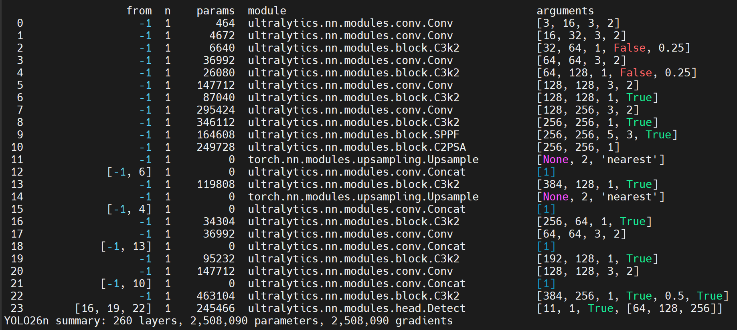

4. Final Model Comparation

